Q1. Build inverted index.

Input Split 1 (Doc ID 101) [ cat pat mat sat cat eat ]

Input Split 2 (Doc ID 201)  [ pat mat sat pat mat eat]

Input Split 3 (Doc ID 301) [ sat mat cat pat fat mat]

Assume three Mappers and two Reducers.

Let cat mat and sat be processed by Reducer 1 and rest by Reducer 2.

Q2 Illustrate Page Rank Algorithm **(Three steps only).**

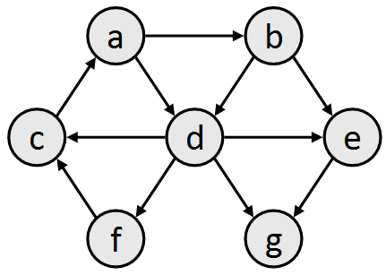

Q3 Apply all the data compression algorithm covered in class by the professor through examples on the following list of postings.

[(512, 15), (2080, 93), (5748, 195), (7080, 255]